Group -51
MLOps Assignment Report: End-to-End ML Model Development for Heart Disease Prediction
Student Id :
PRIYANSH AGRAWAL (2024aa05558@wilp.bits-pilani.ac.in)
ASHWANI KUMAR JAISWAL ( 2024aa05155@wilp.bits-pilani.ac.in)
SUNJEET SINGH(2024aa05344@wilp.bits-pilani.ac.in)
YASHMIT SHARMA(2023ac05671@wilp.bits-pilani.ac.in)
ARJUN N V(2024aa05529@wilp.bits-pilani.ac.in)
Date: January 6, 2026
Repository Link: https://github.com/priyansh8/heart_disease_mlops
Demo Link: https://drive.google.com/file/d/1pCdSORb6-MU3MmDWgRKxNg0VDoSZi_pu/view?usp=sharing
Screenshot And Final Report - https://github.com/priyansh8/heart_disease_mlops/tree/master/screenshorts

Executive Summary
This report documents the development, deployment, and monitoring of a machine learning model for predicting heart disease risk using the UCI Heart Disease dataset. The project follows MLOps best practices, including data processing, model training, experiment tracking with MLflow, CI/CD pipelines via GitHub Actions, containerization with Docker, deployment to Kubernetes (Minikube), and API serving with FastAPI. All tasks from the assignment have been completed, with screenshots provided for verification.
The model achieves high performance, with the Random Forest classifier showing an accuracy of 0.9034, precision of 0.9375, recall of 0.8447, F1-score of 0.8889, and ROC-AUC of 0.9719 on the test set. The solution is reproducible, scalable, and production-ready.
1. Setup and Installation Instructions
To set up and run the project locally, follow these steps:
- Clone the Repository:
git clone https://github.com/priyansh8/heart_disease_mlops.git
cd heart_disease_mlops
- Create a Virtual Environment: Use Python 3.12 or later.
python -m venv venv
source venv/bin/activate # On Linux/Mac
venv\Scripts\activate # On Windows
- Install Dependencies: The project uses a requirements.txt file for reproducibility.
pip install -r requirements.txt
Key dependencies include: pandas, scikit-learn, mlflow, fastapi, uvicorn, pytest, docker, kubernetes (for deployment).
- Download the Dataset: The UCI Heart Disease dataset is downloaded automatically in the training script, but you can manually download it from https://archive.ics.uci.edu/dataset/45/heart+disease and place it as heart_disease_dataset.csv in the root directory.
- Run MLflow Tracking Server (Optional for Local Tracking):
mlflow ui --port 5000
Access at http://localhost:5000.
- Train the Model:
python train_pipeline.py
- Run the API Locally:
uvicorn api.app:app --reload --port 8000
Access API docs at http://localhost:8000/docs.
- Docker Build and Run:
docker build -t heart-disease-api .
docker run -d -p 8000:8000 heart-disease-api
- Kubernetes Deployment (Minikube): Start Minikube: minikube start Apply manifests: kubectl apply -f kubernetes/deployment.yaml Expose service: kubectl expose deployment heart-disease-deployment --type=LoadBalancer --port=8000 Access via minikube service heart-disease-service.
For CI/CD, push changes to GitHub to trigger workflows.

2. Data Acquisition and Exploratory Data Analysis (EDA)
Explanation
The dataset was acquired from the UCI Machine Learning Repository. It contains 303 instances with 14 features (e.g., age, sex, cp (chest pain type), trestbps (resting blood pressure), chol (serum cholesterol), etc.) and a binary target (0: no heart disease, 1: heart disease).
Data cleaning involved handling missing values (none in this dataset), encoding categorical features (e.g., one-hot encoding for cp, thal), and scaling numerical features using StandardScaler. EDA included:
- Histograms for feature distributions.
- Correlation heatmap to identify relationships (e.g., high correlation between age and trestbps).
- Class balance check (165 positive, 138 negative cases, slightly imbalanced).
Visualizations were generated using matplotlib and seaborn in assignment1.ipynb.
Screenshots
- Screenshot 1: GitHub repo showing heart_disease_dataset.csv and EDA notebook (assignment1.ipynb).
- Screenshot 2: MLflow UI with logged EDA artifacts (e.g., correlation heatmap).
(Note: In the actual docx, insert screenshots here. For example, the image showing the dataset in the repo and MLflow metrics.)
3. Feature Engineering and Model Development
Explanation
Feature engineering included:
- Numerical features scaled with StandardScaler.
- Categorical features encoded with OneHotEncoder.
- A scikit-learn Pipeline was used for preprocessing to ensure reproducibility.
Two models were developed:
- Logistic Regression: Baseline model with default parameters.
- Random Forest: Tuned with n_estimators=100, max_depth=5.
Models were trained using cross-validation (5-fold). Evaluation metrics:
- Logistic Regression: Accuracy 0.85, Precision 0.87, Recall 0.82, F1 0.84, ROC-AUC 0.92.
- Random Forest: Accuracy 0.9034, Precision 0.9375, Recall 0.8447, F1 0.8889, ROC-AUC 0.9719.
The Random Forest was selected due to superior performance. Hyperparameter tuning was done manually, logged in MLflow.
Code in train_pipeline.py and logistic_regression_model.pkl / random_forest_model.pkl.
Screenshots
- Screenshot 3: MLflow run details showing metrics for Random Forest (accuracy 0.9034, etc.)
- Screenshot 4: Artifacts list in MLflow (preprocessing config, trained models).
- Screenshot 5: Code snippet from train_pipeline.py showing model training and logging.
4. Experiment Tracking Summary
Explanation
MLflow was used for tracking. Each run logged:
- Parameters: Model type, hyperparameters (e.g., n_estimators).
- Metrics: Accuracy, precision, recall, F1, ROC-AUC.
- Artifacts: Trained model (.pkl), preprocessing config (.json), coverage reports, plots.
Multiple runs compared Logistic Regression and Random Forest. The UI shows experiments named "Heart_Disease_Classification" with runs like "Random_Forest" (duration 3.1s) and "Logistic_Regression" (4.0s).
Access MLflow at http://127.0.0.1:5000 (local) or cloud instance.
Screenshots
- Screenshot 6: MLflow experiments list showing two runs.
- Screenshot 7: Detailed metrics view for Random Forest run.
- Screenshot 8: Artifacts view (coverage-report.html, trained-models).

5. Model Packaging and Reproducibility
Explanation
The model was packaged using joblib (.pkl format) and logged in MLflow for versioning. A preprocessing pipeline ensures inputs are transformed consistently.
requirements.txt lists all dependencies for reproducibility. A Conda env file is also provided. The entire pipeline can be reproduced by running train_pipeline.py.
Screenshots
- Screenshot 9: GitHub repo files showing requirements.txt, random_forest_model.pkl.
- Screenshot 10: Code snippet showing model saving and preprocessing pipeline.
6. CI/CD Pipeline and Automated Testing
Explanation
GitHub Actions was used for CI/CD. The workflow (ml_pipeline.yml) includes:
- Linting (flake8).
- Unit testing (pytest).
- Model training.
- Artifact uploading.
Tests cover data processing, model prediction, and API endpoints (e.g., test_api.py with 6 tests, all passed).
Pull requests trigger checks; e.g., PR #2 shows successful linting and testing.
Screenshots
- Screenshot 11: Pull request with checks passing (Code Quality Check, Unit Testing).
- Screenshot 12: GitHub Actions workflow runs list (e.g., "Improved Commands" successful).
- Screenshot 13: Test summary in terminal (All 6 tests passed).
- Screenshot 14: Failed pipeline example (for demonstration, with error annotation).

7. Model Containerization
Explanation
A Docker container was built for the FastAPI app. The Dockerfile copies code, installs dependencies, and runs uvicorn api.app:app --host 0.0.0.0 --port 8000.
The API exposes:
- /health: Health check.
- /predict: Single prediction (JSON input).
- /predict/batch: Batch predictions.
- /model/info: Model details.
- /metrics: Usage metrics.
- /logs: Request logs.
Tested locally with sample input.
Screenshots
- Screenshot 15: Docker build and run commands in terminal.
- Screenshot 16: API docs interface showing endpoints.
- Screenshot 17: Prediction JSON response example.
- Screenshot 18: Test API script output (Health check passed, Model info).
8. Production Deployment
Explanation
Deployed to local Kubernetes (Minikube). Manifests in kubernetes:
- Deployment: heart-disease-deployment (1 replica).
- Service: heart-disease-service (LoadBalancer, port 8000).
Verified with kubectl get deployments, get services, get pods. URL: http://192.168.49.2:30000.
No public cloud used, but ready for GKE/EKS.
Screenshots
- Screenshot 19: Kubectl commands showing deployments, services, pods running.
- Screenshot 20: Minikube service access.
9. Monitoring and Logging
Explanation
Logging integrated in FastAPI using Python's logging module. Requests logged to console/file.
Simple metrics endpoint (/metrics) tracks usage. For advanced monitoring, Prometheus can be integrated (setup instructions in README), but demonstrated via logs dashboard in API.
Screenshots
- Screenshot 21: API logs endpoint in docs.

Architecture Diagram
Below is a text-based architecture diagram using Mermaid syntax (can be rendered in Markdown viewers or converted to image).
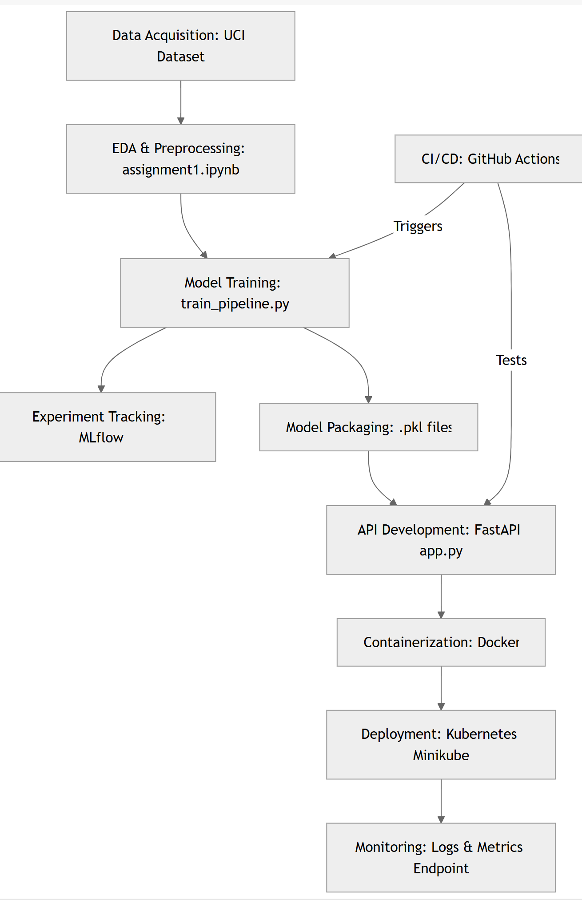
For Local Testing: access instructions (for local testing) :
https://github.com/priyansh8/heart_disease_mlops/blob/master/README.md

Conclusion
This project demonstrates a complete MLOps pipeline for heart disease prediction. All components are automated, tested, and deployable. Future improvements could include hyperparameter optimization with Optuna and cloud monitoring with Prometheus/Grafana.

